SHOPPING

CART

# Table of Contents

1.0 INTRODUCTION. 3

2.0 ABSTRACT… 4

3.2 PROJECT OBJECTIVE. 5

4.0TECHNOLOGY REQUIRED. 6

* 1. SOLUTION STEP… 7
  2. USER REGISTER… 7
  3. UML Diagrams 8
  4. Use Case Diagram… 8
  5. Activity Diagram… 9
  6. Sequence Diagram… 9

**INTRODUCTION**

Shopping Cart is the Process whereas customer directly buy goods, services etc. from a Seller interactively in real-time without an intermediary service over internet. Shopping Cart is the process of buying goods and services from Merchants who sell on the internet. Since the emergency of World Wide Web, merchants have sought to sell their product to people who surf the Internet. Shoppers can visit web stores from their homes and shop as they sit in front of the computer.

Consumers or Customer buy a variety of items from our Shopping Cart website.

The system would be easy to use and hence make the shopping experience pleasant for the users.In the proposed system customer need not go to the shop for buying the products. User can order the product he wish to buy at anytime and from anywhere. The shop owner will be admin of the system.The motive of this Shopping Cart Web Application is to allow the user to play with the search tool and create different combinatorial search criterion to perform exhaustive search.Provide Interactive interface through which a user can interact with different areas of application easily.A search engine that provides an easy and convenient way to search for products specific to their needs. The search engine would list a set of products based on the search term and the user can further filter the list based on various parameters.

# Abstract

Online Shopping Cart System is a web-based shopping system for an existing shop. This project delivers the online shopping application. Shopping cart is the process where users can directly buy goods in real-time. Users can buy products without an intermediary service on the Internet. This project is a form of e-commerce. Selected products can be added to the cart. Products added to cart can be purchased later also. Thus, the customer will get the service of online shopping and home delivery from his favourite shop.The current system can be extended to allow the users to create accounts and add products in to the cart.This system can be implemented to any shop in the locality or to multinational branded shops having retail outlet chains. The system recommends a facility to accept the orders 24*7 and a home delivery system which can make customers happy.If shops are providing an online portal where their customers can enjoy easy shopping from anywhere, the shops won’t be losing any more customers to the trending online shops such as flipkart or ebay.

# Project objective

* To develop an easy-to-use web-based interface where users can search for products, view a complete description of the product, and order the products.
* The user can easily add a product to or remove a from the shopping cart.
* A user can view the complete specification of the product from along with various images.

* User must go to shop and select products.
* It is difficult to identify the required product.
* Description of the product limited.
* It is a time consuming process.
* Not in reach of distant users.

# Technologies Required

|  |  |  |
| --- | --- | --- |
| No. | Name | Description |
| 1. | API | USING HTTP REQUEST WE WILL USE THE RESPECTIVE ACTION TO TRIGGER THE VARIOUS OPERATIONS |
| 2. | ANGULAR | TO CREATE AND DESIGN THE FRONTEND |
| 3. | DATABASE | TO STORE AND RETREIVE THE INFORMATION |

* 1. **Solution Steps**
  2. User registration

The is for the User/Customer and Merchant to Login/Sign Up for the Web application.

* For Login, we are going to use email and password.
* For Sign Up, we are going to use name, email, phone number, password, and address.

# UML DIAGRAM

**USE CASE DIAGRAM**

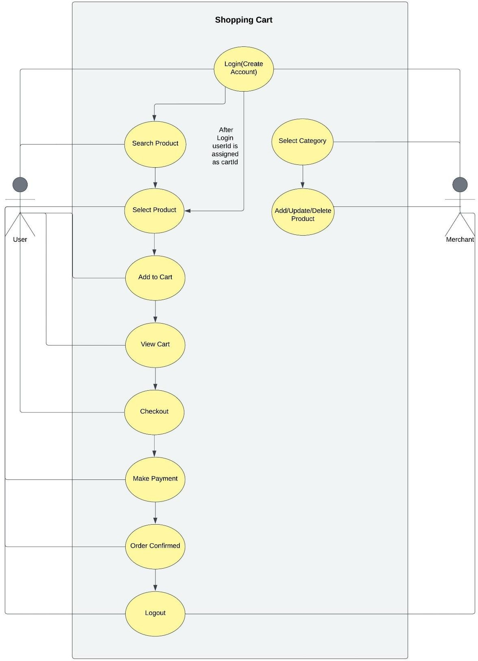

# User side Activity Diagram

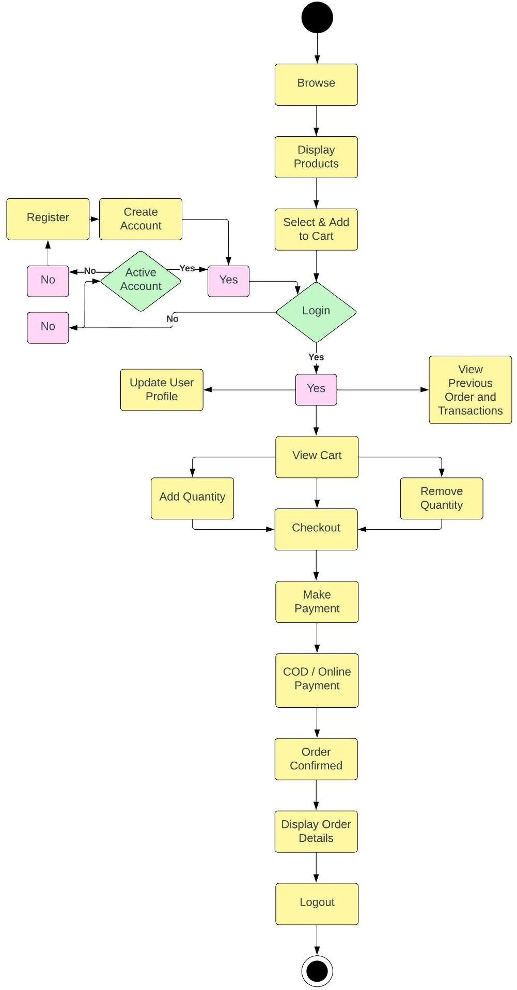

**Merchant side activity diagram**

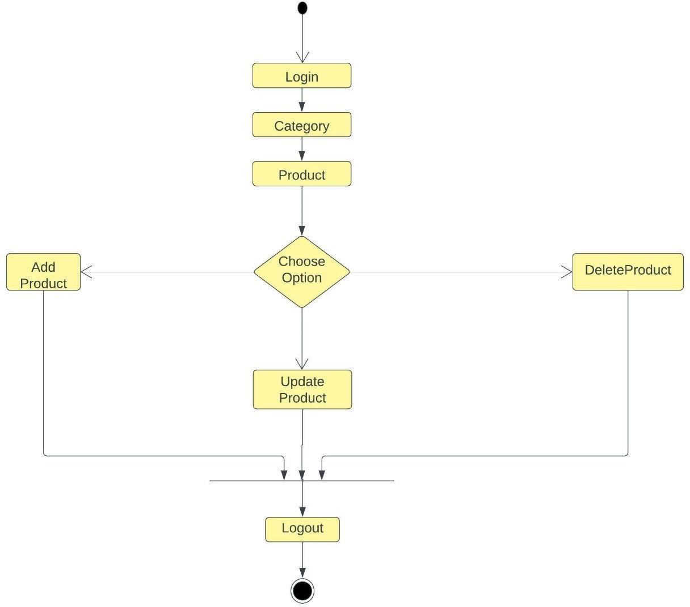

**User side Sequence Diagram**

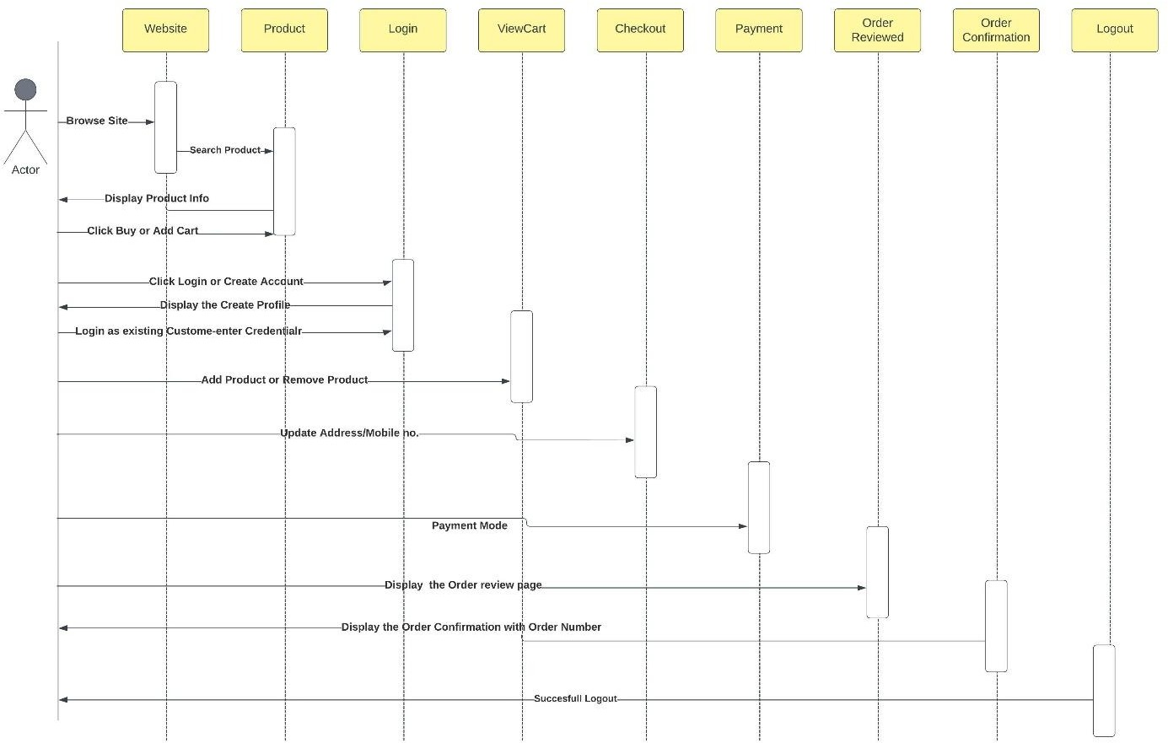

**Merchant side Sequence Diagram**

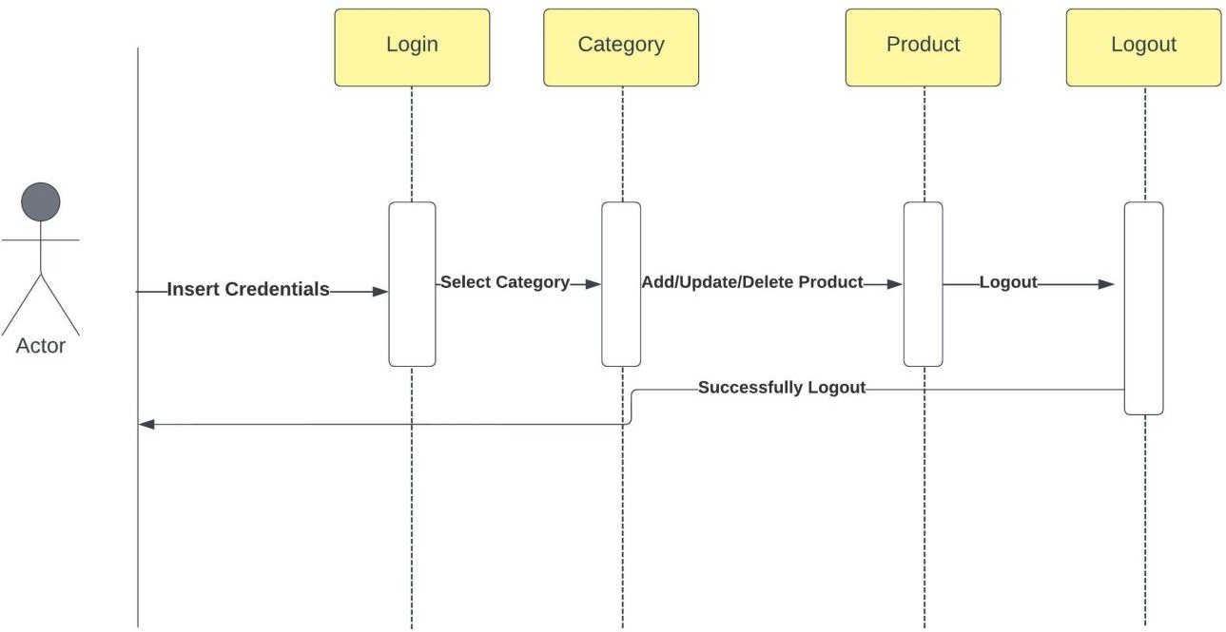

**Database Diagram**

